 

**Phase 4: Performance of the project**

**Name**: Lourdhu priscilla A

**Reg No**: 311623244013

**College Name**: Misrimal Navajee Munoth Jain Engineering College

**College code**: 3116

**Department** : Computer Science And Business Systems

**Title: AI-Driven Natural Disaster Prediction &Management System**

# Objective:

# The focus of Phase 4 is to enhance the Cyclone and Storm Prediction and Management System's performance by refining predictive models, optimizing for scalability, improving responsiveness and IoT integration.

# 1. Interactive Storm Tracker

# - Overview: This phase will optimize the interactive storm tracker, providing a seamless and efficient experience for users to visualize predicted cyclone/storm paths and plan accordingly.

# - Key Enhancements:

# 1. Map Updates: The system will be optimized to display predicted cyclone/storm paths,ensuring users receive timely updates.

# 2. User-Friendly Interface: The interactive map will be fine-tuned to ensure it is easy to use and understand for all literacy levels.

# - Outcome: By the end of this phase, users will be able to visualize predicted cyclone/storm paths and plan accordingly with minimal latency.

# 2. Personalized Alerts

# - Overview: This phase will optimize the personalized alert system, ensuring users receive timely and relevant notifications when a cyclone/storm is predicted to affect their area.

# - Key Enhancements:

# 1. Optimized Alert Triggers: The system will be enhanced to trigger alerts based on predicted weather conditions, ensuring users receive timely notifications.

# 2. Improved Notification Delivery: API calls will be optimized to ensure faster and more reliable delivery of visual notifications to users.

# - Outcome:Users will receive timely and relevant alerts for their areas, enabling them to take necessary precautions.

# 3. IoT-enabled Proactive Tree Trimming

# - Overview: This phase will optimize the IoT-enabled proactive tree trimming system, providing insights and recommendations for proactive tree trimming to prevent roadblocks and power outages.

# - Key Enhancements:

# 1.Data Processing: The system will be optimized to handle data streams from IoT devices, reducing latency in collecting and processing tree health data.

# 2. Advanced Predictive Analytics: Machine learning algorithms will be fine-tuned to analyze data and predict potential tree failures, enabling proactive tree trimming.

# - Outcome:The system will provide insights and recommendations for proactive tree trimming, reducing the risk of roadblocks and power outages.

# 4. Evacuation Ticket Booking

# - Overview: This phase will optimize the evacuation ticket booking system, allowing users to book evacuation tickets or transportation services to safe zones before cyclones and storms.

# - Key Enhancements:

# 1. Streamlined Booking Process: The system will be optimized to facilitate fast and secure ticket booking, integrating with payment gateways and APIs to fetch evacuation routes and schedules.

# 2. Real-Time Availability: The system will be fine-tuned to display availability of evacuation tickets and transportation services, enabling users to plan accordingly.

# - Outcome: By the end of this phase, users will be able to safely evacuate to designated safe zones with minimal hassle.

# 5. Community Forum and Resource Hub

# - Overview: This phase will optimize the community forum and resource hub, providing a platform for users to share information and get support during cyclone/storm events.

# - Key Enhancements:

# 1. Enhanced Forum Platform: The forum platform to enable seamless sharing of information and discussion of cyclone/storm-related topics.

# 2. Curated Resources: Links to emergency services, government websites, and other relevant resources will be updated to ensure users have access to timely information.

# - Outcome: By the end of this phase, users will be able to share information and get support from the community, and access relevant resources to mitigate the impact of cyclones/storms.

# Key Challenges in Phase 4

# 1. Scaling the System:

# - Challenge: Ensuring the system can handle increased user traffic and more complex storm prediction queries.

# - Solution: Extensive load testing and model optimization will ensure the system maintains speed and accuracy under high loads.

# 2. Data Reliability:

# - Challenge: Ensuring the accuracy and reliability of storm prediction data and forecasts.

# - Solution: Implementing robust data validation processes, using multiple data sources, and continuously updating predictive models with new data to improve forecast accuracy.

# 3. IoT Device Integration:

# - Challenge: Ensuring seamless integration with a wide variety of IoT devices (e.g., weather sensors, storm monitoring devices).

# - Solution: Optimize API calls and conducting extensive device compatibility tests to ensure the system can handle data from a broad range of IoT devices.

# Here are the outcomes of Phase 4 for the Cyclone and Storm Prediction system:

# Outcomes of Phase 4

# 1. Improved Prediction Accuracy: The predictive model will provide more accurate storm forecasts, enabling users to take necessary precautions.

# 2. Enhanced System Performance: Users will experience smoother and more intuitive interactions with the system, with reduced latency and improved responsiveness.

# 3. Optimized IoT Data Integration: Real-time data from IoT devices will be collected and processed with minimal delay, enhancing the system's ability to provide accurate storm predictions.

# Next steps for finalization:

# The Cyclone and Storm Prediction and Management system will be fully deployed in the upcoming final phase, where further feedback will be gathered to fine-tune the predictive model and optimize the overall user experience before the official launch.

**Screenshots for code and progress:**

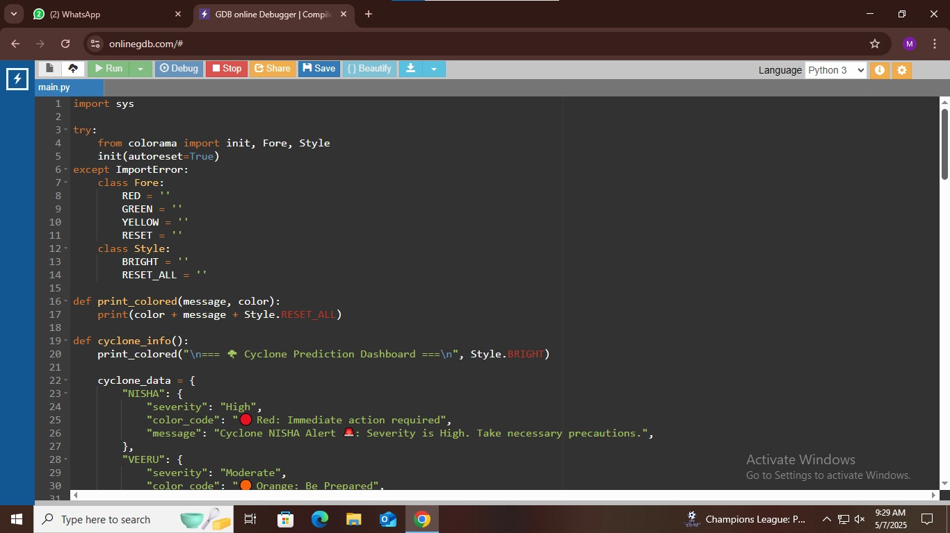

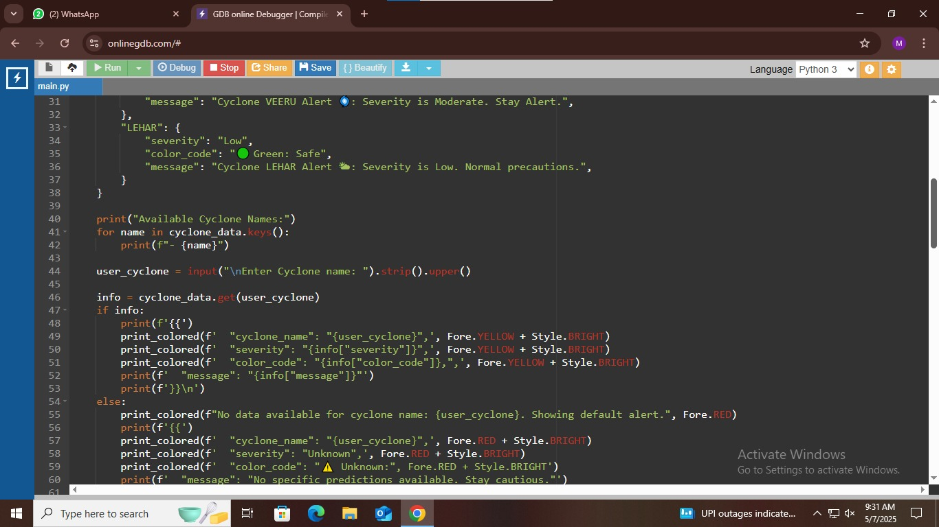

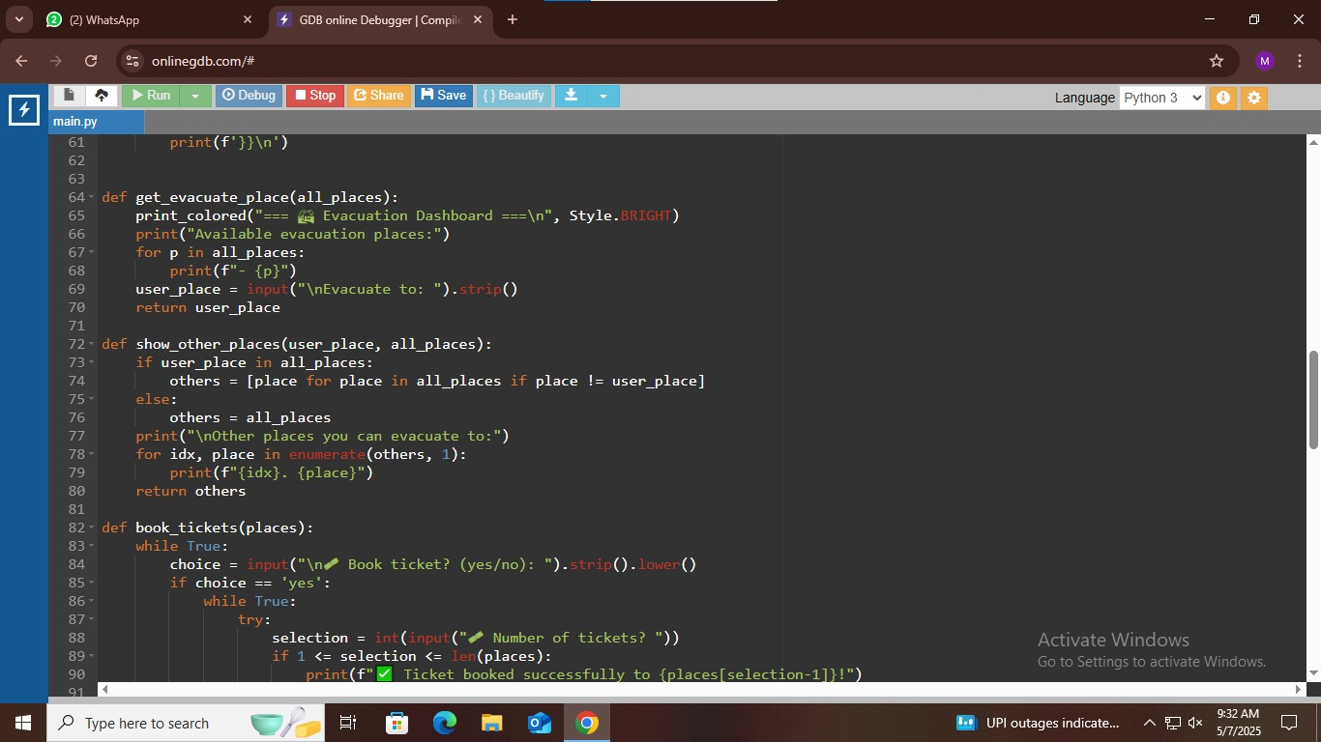

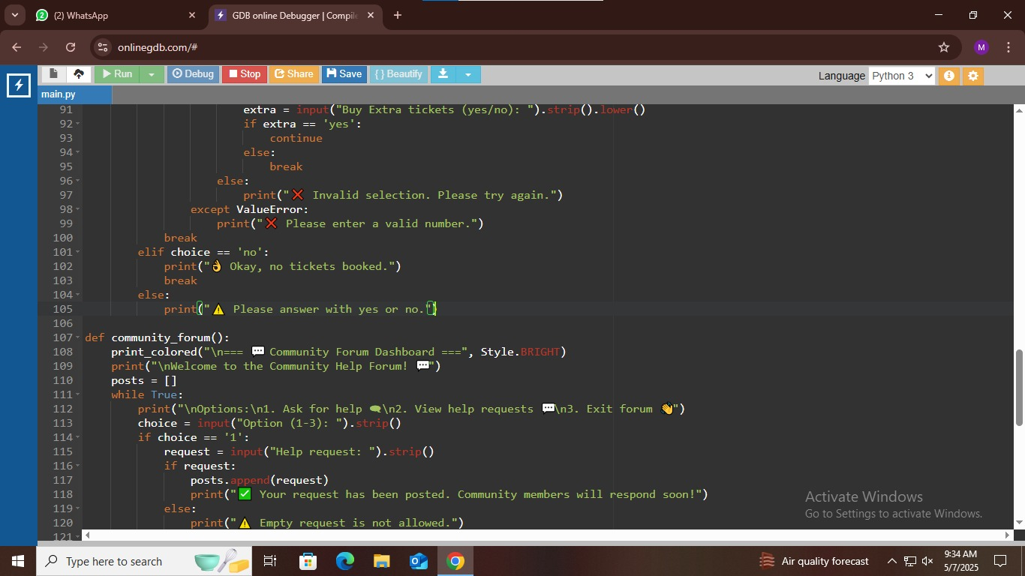

**Output:**

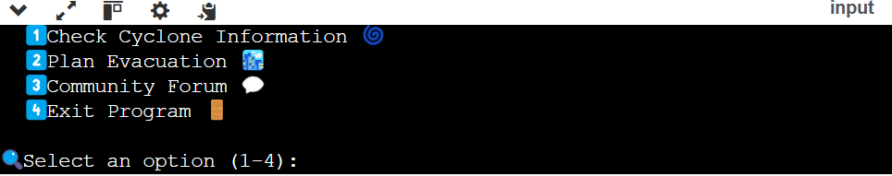**z**

**TEAM MEMBERS:**

1. Kanagavel M(311623244011)
2. Nivethitha P(311623244016)
3. Karthikeyan(311623244012)
4. Thivahar J(311623244022)